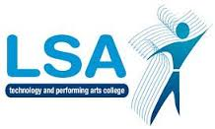
LSA ENGLISH DEPARTMENT

L

Y8 Assessment Summary for Parents 2017-8

Date | Topic/Task | Type of Assessment
Assessment 1  Sept - Dec | Speech (10%)  Mood & atmosphere extract (10%)  (20% of whole year assessment) | Formal assessment  Skills practice assessment
Assessment 2  Jan - March | Review of novel (10%)  Poetry analysis (15%)  Leaflet (5%)  (30% of whole year assessment) | Formal assessment  Skills practice assessment  Skills practice assessment
Summative  Assessment  April - July | Speech (20%)  Non-fiction comprehension (30%)  (50% of whole year assessment) | Examination  Examination

- nb: timings are subject to variation if the class is split between two teacher

