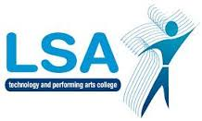
LSA ENGLISH DEPARTMENT

L

Y11 Assessment Summary for Parents: GCSE English Language & English Literature 2017-8
Date | Topic/Task | Type of Assessment
Assessment 1  Sept - Nov | How is a character presented LOTF/AIC?  (100% Asst 1)  ACC extract question | Formal assessment  Skills practice assessment
Assessment 2  Dec – February  (mocks) | Fiction comprehension (50% Asst 2 lan)  Story (50% Asst 2 lan)  Macbeth essays (50% asst 2 lit)  Poetry anthology essay (50% asst 2 lit) | Mock examination  Mock examination  Mock examination  Mock examination
Summative  Assessment  March - April | Non-fiction comprehension  Job application letter | Skills practice assessment  Formal assessment

