Helping your child in the transition from Primary School to LSA.

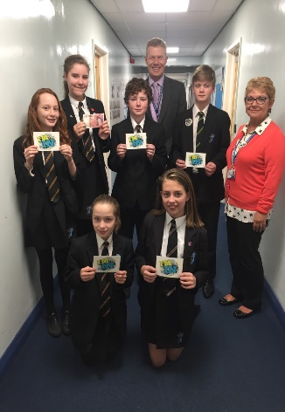
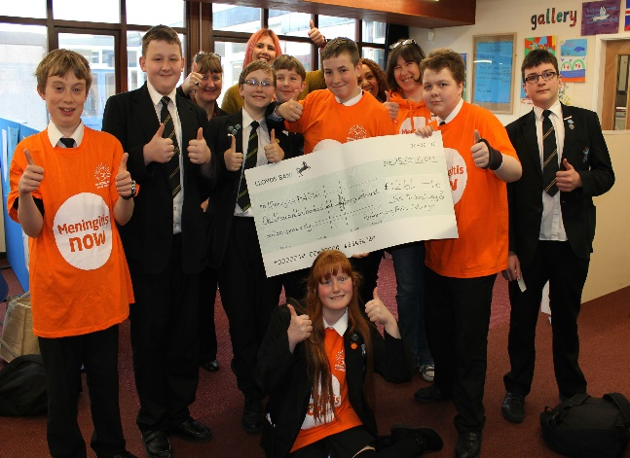
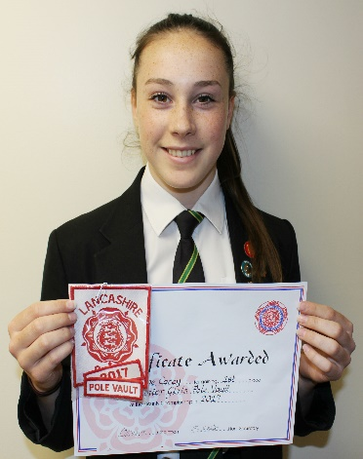
Parent Booklet

“A learning community in pursuit of excellence”
Who should I Contact?
The school website contains lots of information and is a useful first point of call.
If you require more information, please use the following methods of contact.
Curie – 01253 667389
Newton – 01253 667390
King – 01253 667336
Lennon – 01253 667350
Holmes – 01253 667304
Whittle – 01253 667310
Use the contact page on the school website
www.lythamhigh.lancs.sch.uk/contact

Your child’s College Leader
General Enquiries
Ring School main reception on
01253 733192
Ask to be put through to either the class teacher or the head of subject
Anything else including pastoral issues
Subject specific enquiries
My child is going to be absent from school
Ring the school absence line on 01253 667411 or message through the MyED app.
Uniform
- Black knee length skirt (banner 3596 Henley – 18” minimum length with school emblem) or black tailored trousers
- Black blazer and badge
- School tie (In Year 7 this will be _____)
- Plain black cardigan/pullover with V neck (optional)
- White/black socks/tights
- Sensible shoes in black, brown or grey – heels should not be more than 4cm
General Appearance
- Extreme hairstyles are discouraged. Students are not allowed to have patterns in their hair or dye their hair vivid or multiple colours.
- No jewellery is allowed to be worn in school – except a watch and one small plain stud in each ear.
- Pumps made of canvas, boots or shoes with sports logos, writing or patterns are not acceptable forms of footwear for school.
- Hooded tops, fleeces, tracksuit tops, baseball caps and denim jackets should not be worn in school.
- Outdoor garments displaying obscene or offensive words or images are not appropriate for school.
- Students must not wear nail varnish, acrylic or ‘fake’ nails.
- Students must not have any visible tattoos.
- Where additional items of uniform are worn for religious reasons, these should be black.
Please support our attempts to maintain high standards of appearance. The school reserves the right so send home any student who does not meet these expectations.

PE Kit – Compulsory
- Black shorts (not cycling shorts)
- White polo shirt or black rugby top with blue hoop
- Black athletics vest with blue hoop
- Black sports socks
- Sports trainers (not fashion pumps)
- Football boots (required for rugby or football)
PE Kit – Optional
- Plain black tracksuit bottoms (optional between November and April)
- Plain black sweatshirt (not hooded)
- Base layers for an extra warm layer are available and can be worn for all lessons. Plain black or white. Base layers with the school logo on can be purchased from www.playerlayer.com

Uniform Suppliers

Katie Richards
138 St Albans Road
FY8 1UY
01253 729840
www.katierichards.net

Top Marque
7a Park Road
FY8 1QX
01253 725246

1st Class Kids
106-108 Highfield Road
FY8 2JF
01253 403798
www.1stclasskids.co.uk

The Uniform and Leisurewear Company
31 Clifton Street
FY1 1JD
www.ualonline.co.uk
Tavernor’s
29 Clifton Street
FY8 5ER
01253 736497

Attendance and Punctuality
What time does school start?
8:40am. If students are not in form by the time the second bell rings, they will be marked as late by their Form Tutor.
Does LSA allow holidays during term time?
No. Holidays during term time will NOT be authorised.
How many lessons has my child missed if they have 90% attendance?
100 lessons which is equal to 4 weeks of school. This will impact on a students attainment at, and enjoyment of, school. Students should aim for at least 95% attendance or above.
Can I check my child’s attendance?
Attendance and punctuality can be checked on the MyEd school app and can be seen on school reports.
I am struggling to ensure my child attends school and is punctual, what should I do?
It is a parent/carer’s legal responsibility to ensure that their child receives a full time education, this not only means regular and punctual attendance bur that the child attends fit and ready to learn.
Parents should liaise with the school via form tutor, college leader and the attendance team if this becomes a struggle. The school will then provide support, information and guidance where this is reasonably possible.
If my child is off school, how should I inform LSA?
You can ring the school’s discrete attendance line on 01253 667411. Parents/carers are asked to ring or message through the MyED app before 9am on the first and each day of absence.
If the school has not been notified of a student’s absence, parents will be notified by text message. It is important the school has an up to date mobile number for this purpose.
Electronic Systems
My Ed is the school app we use at LSA. This is really useful for sharing valuable information with parents and carers. The app is available for most android and apple devices.
The app is the messaging service used by teachers and admin staff to send information about trips, lesson commitment, behaviour issues and attendance alerts.
As well as the messaging feature, My Ed allows you to view information and keep up to date with what’s going on in school. You can also view your child’s attendance, timetable and behaviour incidents.
You can download MyEd now. Your child will be linked in September.
Vivo is the rewards system we use at LSA. Students can be rewarded for things such as outstanding lesson contribution, extra-curricular commitments and 100% attendance. Students spend their vivos in the online gift shop.
You will be given log in details in September so you monitor how your child is progressing, how many vivos they have and who they have received them from.

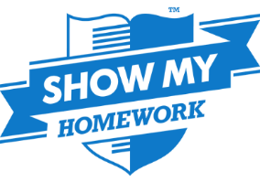
Teachers will put any homework they give out on Show My Homework. You can download the SMHW app or access it online. This will show you the task and the due date for tasks your student has been set. You will receive a pin, which allows you to log in and view your child’s homework.

ParentPay is the cashless catering system used in school to allow students to purchase food during the school day. You will be given a username and password to create an account in order to ‘top-up’ a student’s account. Using ParentPay is safer than students bringing money to school and is an instant way to ensure they have credit on their lunch account.
Library
OPEN: 8:15am to 4:45pm Monday to Thursday and until 4pm on Friday
Freely open to all before school, at break, lunchtimes and afterschool every day. Everyone is welcome in the Library.
What can you use the Library & LRC for outside of lesson time?
Reading
- Students borrow 10,000 books every year and take part in the Accelerated Reader scheme.
- You do a Star Test to set your ZPD level (It is just multiple-choice questions).
- From your ZPD level, you get help finding books to fit your reading ability.
- You quiz on books you read to gain points and grow your word count.
- Each year, about 100 students become millionaire readers.
- Guest authors and trips to events.
Equipment
- You get free printing and photocopying.
- Choose from about 16,000 books.
- Use our scissors, plastic backing, glue, colours, guillotine, paper, pens etc.
- You will be able to code and assemble robots and print in 3d.
- An amphitheatre area for films, podcasts and audio books.
- Equipment so that you can make animated films and other creative ways to complete homework using your phone.
Community
- Quiet reading area with a totally silent study space coming soon.
- A place to play games like Chess or Articulate.
- The Library LRC is also a workplace for students where you can apply to volunteer, learn new skills and to earn Vivos in your free time.
- Parents and Friends of the School are BIG supporters of the Library.
PTFA

A warm welcome to all parents, teachers and friends of LSA to the PTFA.
The PTFA has a few key objectives:
- To develop extended relationships between staff, parents and others associated with the school.
- To engage in activities which support the school and advance the education of its pupils
- To assist in the provision of facilities, not normally provided by the Local Education Authority, for education at the school.
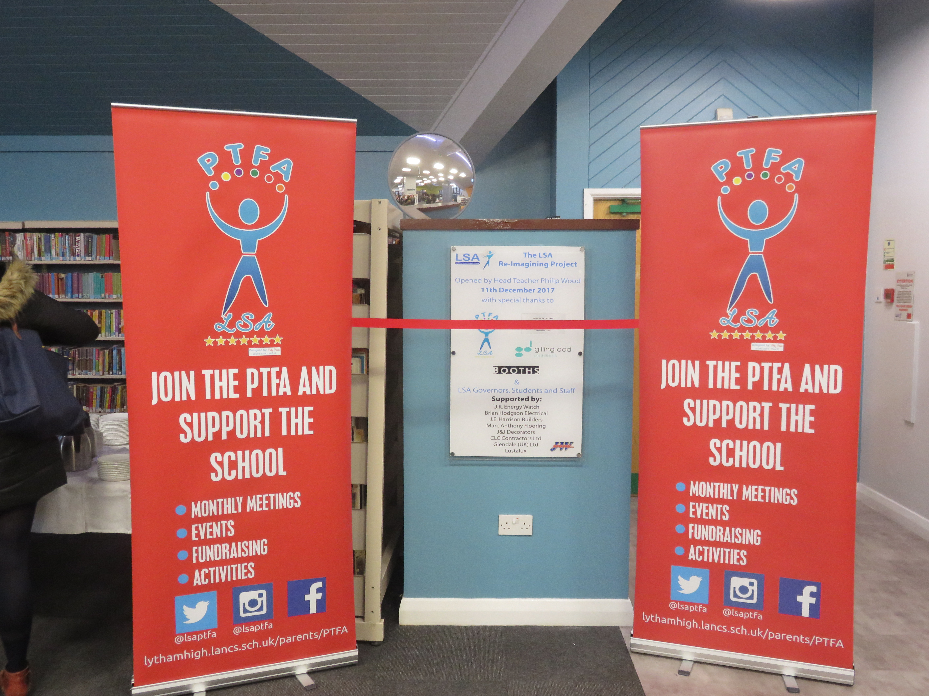The PTFA for LSA meets the first Thursday of each month (usually) at 7.30pm in the School Library. The meetings last around an hour and it’s a great opportunity to meet with other parents. At each meeting the Head Teacher has a slot on the agenda which provides an excellent opportunity to talk about important/topical school issues.
At the meetings we plan our future fund-raising events, discuss the distribution of funds raised and how the PTFA can support the school.
A key role provided by the PTFA is the provision of refreshments for staff and visitors at Parents’ Evenings, Careers’ Evenings and evenings where the pupils are staging events e.g. Music Evenings etc.
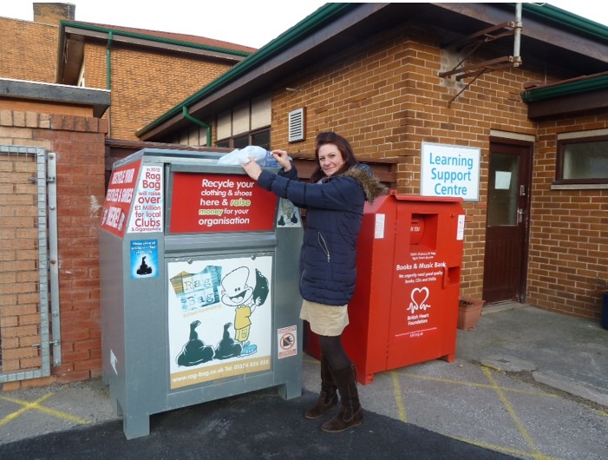We welcome your support whether that is at our monthly meetings or supporting one of the many events we hold to raise funds.
Alternatively you can get involved by joining one of the following schemes: Rag Bag Collection Scheme, Easy fundraising and Lucky Numbers. All the details for these Schemes can be found on the PTFA section of our website.
Term and Holiday Dates 2018-19

Autumn Term 2018

Re-open on | INSET Day Monday 3rd September  Tuesday 4th September 2018 for Year 7  Wednesday 5th September 2018 for all Years
Mid Term Closure
 | Monday 22nd October - Friday 2nd November 2018 (inclusive)
Closure after school on | Friday 21st December 2018 at 12.30pm

Spring Term 2019

Re-open on | Monday 7th January 2019
Mid Term Closure | Monday 18th February - Friday 22nd February 2019 (inclusive)  INSET Day Monday 25th February
Closure after school on | Tuesday 9th April 2019 at 3.10pm

Summer Term 2019

Re-open on | Tuesday 23rd April 2019
May Day Closure | Monday 6th May 2019
Mid Term Closure | Monday 27th May - Friday 31st May 2019 (inclusive)
Closure after school on | Tuesday 23rd July 2019 at 12.30pm

