

***“A learning community in pursuit***

***of excellence”***

**Options Booklet 2019**



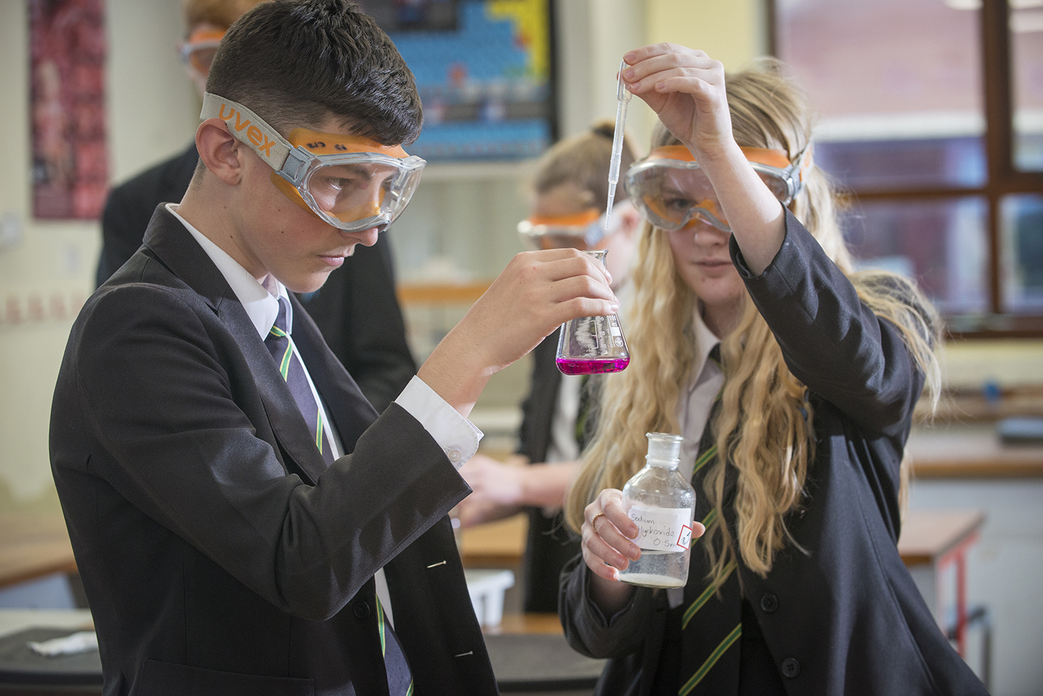

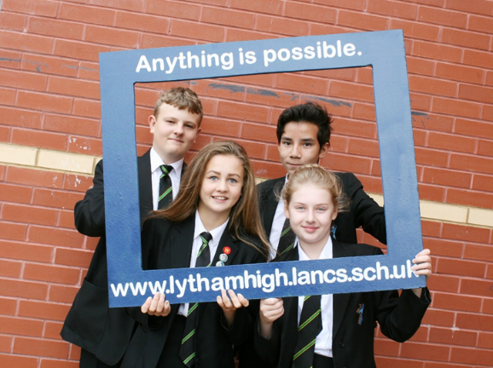



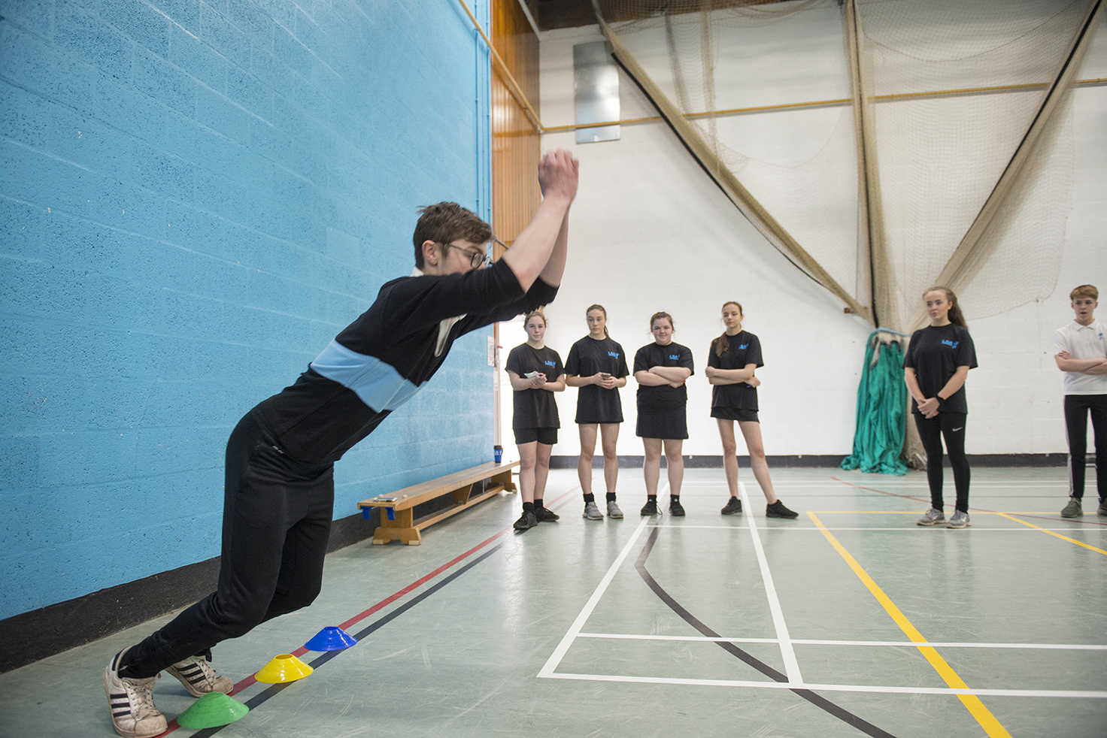

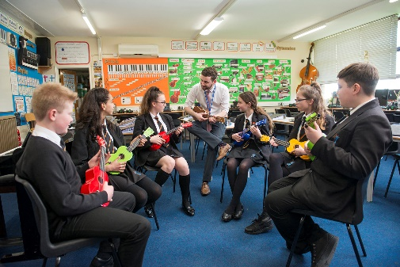



***Aspiration - Endeavour - Integrity - Respect***

**CONTENTS**

Introduction from the Head Teacher

General Information

**SUBJECT PAGES**

Art and Design – GCSE

Business Studies – GCSE

Computer Science – GCSE

Creative Media Production – Technical Award Level 1 / 2

Design and Technology – GCSE

Drama - GCSE

Engineering – Technical Award Level 1 / 2

English Language – GCSE

English Literature – GCSE

Food, Nutrition and Preparation – GCSE

French – GCSE

Geography– GCSE

German – GCSE

History – GCSE

Mathematics – GCSE

Music – GCSE

Performing Arts – Technical Award Level 1 / 2

Physical Education – GCSE

Religious Studies – GCSE

Science (Combined Science) GCSE

Science (Single Sciences) GCSE

Sport Studies – Cambridge National Level 1 / 2

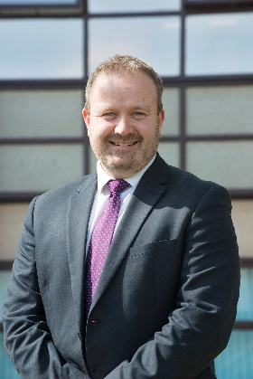**Dear Parents, Carers and Students,**

Thank you for taking the time to read this booklet, to ask questions and support your child in making their curriculum preferences.  
  
This process is about making choices for the right reasons and taking the opportunity to study and enjoy subjects in more depth.  In effect, this is a major step in your child's school life, but one that will be made as smooth as possible.  
  
With a proud history of excellent achievement and results, this process will allow you to find out about the subjects we offer, as well as pathways and opportunities after LSATPAC. We have excellent relationships with post 16 providers and the more you know about the possibilities now, the more likely your child is to succeed.   
  
**Partnership**  
It is important that these decisions are made by parents, carers, students and the school together. Please take time to find out what the courses entail as well as looking at how your child has performed in recent years. There will be opportunities at the Options Preference Evening, as well as the Parents’ Consultation Evening to ask questions and find out more.  
  
**Preference?**  
With such a comprehensive range of qualifications and subjects, it is important that all students make a list of preferences. The school will then work with the students to try and offer the top choices. However, as this is not always possible, it is vital that you know as much as you can about as many subjects as possible.

**Do’s and Don'ts**  
It is important that the preferences are well thought out. We know students will perform better in subjects they like, enjoy and have a passion for. Students must not choose subjects because of a particular teacher, or because their friends are choosing it. Groups, teachers and timetables can and will change!  We believe in the importance of keeping as many options available to students when they leave here as possible, therefore will work with students to encourage a balanced set of subjects.  Likewise, we will also ensure that a potential career choice is not obstructed by option choices.  
  
**Challenge of Courses**  
You will be aware that education in the UK has undergone a number of dramatic changes. All subjects have examination elements and there is a greater emphasis on high quality, written answers. Literacy and factual recall are required. As all 13 year olds can improve in both areas, the curriculum will be set up to ensure this happens throughout Year 9, 10 and 11.  
  
**The Booklet and Evening**  
This booklet has been put together to give a brief overview of the subjects we hope to offer. Please take time to read through and think of questions to ask the staff. If, as a student, you want to know more, please speak to the teachers in school.  
  
There is much talk in the press at the moment about schools starting the options process earlier than we did five years ago.  This is an important debate as there are some schools who have implemented options early purely for results.  I can assure parents that this was not our reason. We have a strong set of values that underpin our work and we want the absolute best for our students.  We know that successful outcomes can be one of the greatest springboards to a successful career and life.  Starting this process in Year 8 is an exciting chance for students to develop a genuine love and passion for their subjects.  It is also an excellent opportunity for the school to ensure that students are supported as early on as possible, to do well and succeed. We hope you enjoy the discussion and interest that this process will create.

Good luck and do well!

Yours faithfully



Mr R Baker

Head Teacher

**GENERAL INFORMATION**

In Years 9, 10 and 11, all students will study a compulsory core of subjects made up of:

* English Language
* English Literature
* Mathematics
* Science (Combined Science or Single Sciences)
* Core Physical Education (non examination)
* PSHCE (LIFE) / Religious Studies (non examination)

**SCIENCE**

Your options preference form indicates whether you should study Single Sciences or Combined Science GCSE. You are strongly advised to take the recommended course in order to secure best progression – this will affect how many other option choices you have.

Students taking Single Sciences study a further 3 subjects.

Students taking Combined Science study a further 4 subjects.

One of these four subjects must be either Computing, French, Geography, German or History.

**PSHCE (LIFE) / RELIGIOUS STUDIES (NON EXAMINATION)**

During the Life lessons, students will receive important careers education, information, advice and guidance so that they have high aspirations and clear progression routes after Year 11. The course will also study a range of personal, social, health and care issues such as relationships, respect, tolerance and global issues including religion.

**CORE PHYSICAL EDUCATION (NON EXAMINATION)**

You will be able to choose to take PE GCSE or Sport Studies as one of your options. However, whether you choose it as an option or not, you will have one lesson of practical Physical Education each week.

**SUBJECT COMBINATIONS NOT ALLOWED**

To ensure you study a broad curriculum, you cannot choose:

Performing Arts BTEC Technical Award

**AND**

Drama GCSE

Similarly you cannot choose:

Sport Studies Cambridge National Level 1 / 2

**AND**

PE GCSE

**OPTIONS DEADLINE**

Please ensure fully completed Options Preference forms are handed in to your Form Tutor on or before 22nd March 2019.

**IMPORTANT INFORMATION**

It is extremely unlikely, but still possible, that the subjects offered may be subject to review should there be any changes in Examination Board specifications or staffing. Parents, carers and students will be informed if any changes need to be made.

Students, parents and carers should understand, that subjects chosen will be studied until the end of Year 11. There is no facility to change or drop a subject.

**ART AND DESIGN**

**GCSE – AQA**

**COURSE OVERVIEW**

GCSE Art and Design will give you an insight into artistic practice through a variety of topics and themes. These range from personal identity to natural form and from 3D design to other cultures.

You will be taught through practical tasks, class discussions, homework, individual tuition, independent study and gallery visits.

**WHAT’S COVERED?**

* Drawing skills.
* Coordination and creative skills.
* Drawing and painting techniques.
* Printing and 3D studies.
* Understanding of artist styles and approaches to work/context.

**

For more information, contact Mr Lonsdale.

**ASSESSMENT**

You will complete set portfolio coursework tasks which will be assessed by your teacher, who will give you a progress mark and feedback. This will account for 60% of your final grade.

There is also an externally set task with extended preparation time and 10 hours of sustained focused study. This accounts for 40% of your final grade.

**STAFF COMMENT**

*“GCSE Art and Design allows students to express themselves through a variety of media and techniques. They also have the opportunity to visit galleries for inspiration and to learn about the History of Art as well as the technical elements.”*

**NEXT STEPS**

This can lead to further study post 16, either A Levels or vocational qualifications. It can also lead to careers in fields such as TV, film, fashion and set design.

**BUSINESS STUDIES**

**GCSE – PEARSON**

**COURSE OVERVIEW**

GCSE Business Studies aids students in gaining a detailed understanding of the aims of businesses, different types of businesses and how businesses operate.

There is a focus on small businesses and the entrepreneurial skills required to run them.

**STUDENT COMMENT**

*******“Business Studies has helped me understand why businesses make certain decisions and the impact they have. It’s great to be able to see what I learn in class working in a real world situation.”*

For more information, contact Ms Fitzpatrick.

**WHAT’S COVERED?**

* Enterprise and entrepreneurship.
* Putting a business idea into practice.
* Economic Context.
* Marketing, Financial, Operational and Human Resource decisions.
* How to ‘grow’ a business.

**ASSESSMENT**

All examinations take place at the end of Year 11.

There are 2 examinations, both worth 50% and they consist of calculations, multiple-choice, short-answer and extended writing questions. Some questions are based on business contexts.

**NEXT STEPS**

This course can lead to A Level Business Studies or related subjects such as Economics or Travel and Tourism.

**COMPUTER SCIENCE**

**GCSE – PEARSON**

**COURSE OVERVIEW**

GCSE Computing will allow you to develop a greater understanding of how computers really work and how technology is best used in an ever-changing society. You will learn skills to solve problems and acquire and apply creative and technical skills.

**STUDENT COMMENT**

*“Computing has allowed me to understand the complex decisions computers make and I’ve really developed my coding skills. The subject is always changing and this keeps it interesting, e.g. cyber-crime.”*



For more information, contact Mr Williams or Ms Fitzpatrick.

**WHAT’S COVERED?**

* Developing an understanding of current and emerging technologies.
* Algorithms in programming.
* Making decisions about using ICT.
* Developing computer programmes to solve problems.

**ASSESSMENT**

The qualification is made up of 2 written papers which are taken at the end of Year 11. This will include both short answers and essay style questions.

**NEXT STEPS**

This course can lead onto further study of Computing or ICT at vocational, academic and degree level.

Careers related to science or maths would benefit from programming skills.

**CREATIVE MEDIA PRODUCTION**

**TECHNICAL AWARD**

**LEVEL 1 / 2 – PEARSON**

**COURSE OVERVIEW**

This course is suited to learners with a preference for practical rather than theoretical learning. Students will cover a range of media topics, creating both an e-zinc and a website.

**WHAT’S COVERED?**

* Digital Media Sectors and Audiences.
* Planning and Pitching a Digital Media Product.
* Digital Publishing Productions – Sourcing, Combining and Organising Materials.
* Website Production .



For more information, contact Mr Williams.

**ASSESSMENT**

Two of the units are internally assessed through production of a portfolio.  In Year 11 students will complete a task under supervised conditions, in class, that is set and marked by the examination board.  This task is worth 40% of the final grade.

**STUDENT** **COMMENT**

*“I really enjoy the portfolio work as it means I can work independently and not all my grade comes from the examination. The practical nature means I can get involved in my work and it’s easy to see how it will help with future jobs”.*

**NEXT STEPS**

This course can lead to either A-levels or BTECs. It is valued by employers due to its practical nature and will be useful for creative careers.

**DESIGN AND TECHNOLOGY**

**GCSE AQA**

**COURSE OVERVIEW**

This course takes a broad view of modern technologies focusing on design and manufacture using all materials and processes. The students will develop a breadth of knowledge which they will need to use creatively and independently when choosing their final project.

**WHAT’S COVERED?**

Understanding how to design in order to meet the needs of users

* Learning about both traditional and ‘Smart Materials’.
* How products work.
* Prototyping and mass production.
* Environmental, sustainability, social & ethical considerations.



For more information, contact

Mrs Ainsworth, Mr Howard and Mr Whitehead.

**STAFF COMMENT**

*“Technology is an essential and integral part of so many aspects of our everyday lives and the subject links to maths, science and other areas across the curriculum.”*

**ASSESSMENT**

The course is made up of one non-examination assessed unit worth 50%, for which they can choose their preferred material. The two hour examination is worth 50% and will cover all aspects of Design and Technology.

**NEXT STEPS**

There are various A Level and vocational courses in Design and Technology, Electronics, Engineering, Fashion and Textiles, and Computing as well as University courses or apprenticeships and careers in all of these fields, both in the UK and abroad.

**DRAMA**

**GCSE – AQA**

**COURSE OVERVIEW**

You will learn how to understand and respond to a range of play texts and stimuli and create the desired impact for your audience.

You will investigate social, historical and cultural influences in society through dramatic presentation or through workshops with industry professionals.

**STAFF COMMENT:**

*“Students who enjoy Drama GCSE tend to enjoy working as a team and collaborating in order to create work for a live audience to enjoy. Your oracy skills will improve rapidly and you will find that as a result of this you have more confidence to speak in other subjects.”*

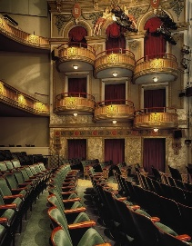

For more information, contact Mr Smith.

**WHAT’S COVERED?**

* Acting.
* Some aspects of technical theatre.
* Devising theatre pieces.

**ASSESSMENT**

You will be assessed in three ways:

* rehearsal and performance of devised and scripted work
* written analysis of this work
* written analysis of a set text and professional live

performance.

60% of your assessment is practical and 40% is written examination.

**NEXT STEPS**

Building your oral and written literacy skills will enable you to succeed in further education or apprenticeships. This course is a good step towards any profession requiring communication and creativity.

**ENGINEERING**

**TECHNICAL AWARD**

**LEVEL 1 / 2 - PEARSON**

**COURSE OVERVIEW**

This course is for learners who wish to acquire technical skills through vocational contexts by studying mechanical, electrical/electronic and engineering design. The Award gives learners the opportunity to develop sector-specific knowledge and skills in a practical learning environment.

**WHAT’S COVERED?**

The course is made up of 3 components:-

* Exploring Engineering Sectors and Design Applications.
* Investigating an Engineering Project.
* Responding to an Engineering Brief.

**ASSESSMENT**

The first two components are internally assessed and the last one has two externally assessed written examinations.

For more information, contact Mr Howard.

**STAFF COMMENT**

*“This is an exciting subject which is closely linked to science, engineering and maths. According to leading manufacturing and engineering companies, STEM based subjects are favoured when recruiting candidates for jobs. Engineering is a growth industry in the UK.”*

**NEXT STEPS**

* A Levels as preparation for entry into higher education in a range of STEM subjects.
* Study of a vocational qualification at Level 3, such as a BTEC National in Engineering, which prepares learners to enter employment or apprenticeships, or to move on to studying a degree in engineering.
* The course has links with companies such as BAE systems and Leyland Trucks Ltd.

**ENGLISH LANGUAGE**

**GCSE – EDUQAS**

**COURSE OVERVIEW**

By the end of your course you will have developed your English skills to the point where you can express yourself in a wide variety of situations, both in written form and orally.

You will develop the ability to write discursively and persuasively. You will acquire many transferable and vital life skills.

**STUDENT COMMENT**

*“I love English Language and it has helped me learn more about different styles of writing. I am now hoping to progress to A Level English language to develop my skills further”.*

**WHAT’S COVERED?**

* Non-fiction (19th Century and 21st Century)**.**
* Fiction texts.

For more information, contact Miss Kendrick.

**ASSESSMENT**

There is only one tier of entry, which allows you to achieve grades 9-1.

The qualification is 100% examination with spelling, punctuation, vocabulary and grammar comprising 20% of the final grade.

**NEXT STEPS**

The wide range of texts that you will study will be the basis of a life-long enjoyment of reading.

Developing your skills in English to gain the best possible grade is vital for progress into further education or a career.



**ENGLISH LITERATURE**

**GCSE – EDUQAS**

**COURSE OVERVIEW**

Studying English Literature will help you develop skills to respond to texts critically, sensitively and in detail.

You will be able to consider different approaches to texts and alternative interpretations.

You will be able to relate texts to social, cultural and historical contexts and literary traditions.

**STUDENT COMMENT**

*“I like studying English Literature because I am able to read and engage with a range of texts from across a long period of time. It helps me in other subjects too like History.”*



For more information, contact Miss Kendrick.

**WHAT’S COVERED?**

You will study several texts during the course, including:

* Prose from 1789 to the present day.
* Post 1914 drama.
* 19th Century Prose.
* Unseen poetry from the 20th and 21st century.
* A play by Shakespeare.

**ASSESSMENT**

English Literature is 100% examination. Students are not permitted to take copies of texts into the examination. Spelling, punctuation, grammar and vocabulary comprise 5% of the overall grade.

**NEXT STEPS**

This course is invaluable to those wishing to continue with arts based courses or for any course or profession requiring the ability to take a critical or analytical stance.

**FOOD, NUTRITION AND PREPARATION**

**GCSE – AQA**

**COURSE OVERVIEW**

GCSE Food, Nutrition and Preparation will allow you to develop a wide range of practical skills that will be of value to you throughout life. These skills include developing practical food preparation techniques to a high level. You will be taught in a variety of ways, including research and practical activities such as sensory analysis and producing finished dishes and products.

**STAFF COMMENT**

*“Students develop cooking skills and knowledge about nutrition and staying healthy. Students are able to make a variety of products.”*



For more information, contact Mrs Hodgkinson.

**WHAT’S COVERED?**

* Food, nutrition and health.
* Food science.
* Food safety.
* Food choice.
* Food provenance.
* Food preparation.

**ASSESSMENT**

The assessment consists of a 1 hour and 45 minute examination worth 50% of the grade. There are also two pieces of controlled assessment to be completed in Year 11: Food Investigation and Food Preparation.

**NEXT STEPS**

Vocational or A Level study including Food, Science, Product Design and PE. It can lead to jobs in the food industry, in nutrition, sports and science, dietetics and biology related careers.

**FRENCH**

**GCSE – AQA**

**COURSE OVERVIEW**

GCSE French will give you an insight into the way of life and cultures of the many countries where the language is spoken.

You will develop social skills, build confidence and develop better oral communication skills.

You will have the opportunity to work independently, in pairs and in groups.

**STUDENT COMMENT**

*“The ability to speak a language is a skill valued by employers due to its rarity in today’s anglo-centric world.”*

**WHAT’S COVERED?**

* ******Identity and culture.
* Local, national, international and global areas of interest.
* Current and future study and employment.

For more information, contact Mrs White.

**ASSESSMENT**

You will be assessed on the four main skill areas:

* Listening.
* Speaking.
* Reading.
* Writing.

There will be three examinations and a speaking test.

All examinations will take place at the end of Year 11.

**NEXT STEPS**

A French qualification will provide a strong foundation for further study and make you stand out from the crowd.

French can be studied at A Level and at University where it can be combined with a variety of other subjects.

**GEOGRAPHY**

**GCSE – AQA**

**COURSE OVERVIEW**

A GCSE in Geography will allow you to develop a deeper understanding of the world in which you live whilst developing analysis, enquiry, numerical, geographical and decision-making skills.

During Geography lessons you will be encouraged to develop your knowledge and understanding using different teaching strategies and media. This knowledge and understanding is then applied to different enquiry questions.

**STUDENT COMMENT**

*“Geography is learning about the real world and how it works. We investigate the impact that natural and human factors have on people and the environment. It is a subject that will give me great knowledge, understanding and skills that I can use in life and my chosen career.”*

For more information, contact Mrs Evans.

**WHAT’S COVERED?**

* Fieldwork, numerical and geographical skills.
* Natural hazards including climate change.
* Ecosystems focusing on tropical rain forests and hot deserts.
* UK physical landscapes including rivers and coasts.
* Urban issues and challenges.
* Changing economic world.
* Resource management focusing on energy.

**ASSESSMENT**

GCSE Geography is 100% examination. There are two compulsory fieldwork trips. At the end of Year 11 there will be three examinations.

**NEXT STEPS**

A Level, degrees or various vocational courses. Careers including business, environmental science, urban planning, and finance.

**GERMAN**

**GCSE – AQA**

**COURSE OVERVIEW**

GCSE German will give you an insight into the way of life and cultures of the many countries where the language is spoken.

You will develop social skills, build confidence and develop better oral communication skills.

You will have the opportunity to work independently, in pairs and in groups.

**STUDENT COMMENT**

*“Learning a language broadens your opportunities, giving you the chance to delve in to a new culture and opening doors to new experiences.”*

****WHAT’S COVERED?**

* Identity and culture.
* Local, national, international and global areas of interest.
* Current and future study and employment.

For more information, contact Miss Constable.

**ASSESSMENT**

You will be assessed on the four main skill areas:

* Listening.
* Speaking.
* Reading.
* Writing.

There will be three examinations and a speaking test.

All examinations will take place at the end of Year 11.

**NEXT STEPS**

A German qualification will provide a strong foundation for further study and make you stand out from the crowd.

German can be studied at A Level and University where it can be combined with a variety of other subjects.

**HISTORY**

**GCSE – PEARSON**

**COURSE OVERVIEW**

Our History course allows students to develop a broad understanding of history from medieval times, through to the present day.

You will be encouraged to debate historical issues, question the reliability of evidence and assess the extent of change.

You will be taught using a range of resources from letters to video footage.

**WHAT’S COVERED?**

* Medicine Through Time.
* Medicine and Surgery on the Western Front in WW1.
* Germany, 1918-1939**.**
* The Reigns of King Richard and King John,
* Superpower Relations, 1941-1991 (Cold War).

For more information, contact Mrs Pountney.

**ASSESSMENT**

All assessment takes place at the end of Year 11 in three examinations.

**STAFF COMMENT**

*“History is a fascinating subject. This course allows students to learn about significant leaders, discoveries, wars and events. There is something for everyone. History is also a great subject for providing you with analysis and research skills.”*

**NEXT STEPS**

GCSE History can lead to A Levels in History, Law and Politics.

History students can go on to have future careers in Journalism, Television, Law, Politics or Teaching.

[](https://www.google.co.uk/url?sa=i&rct=j&q=&esrc=s&source=images&cd=&cad=rja&uact=8&ved=0ahUKEwjttpiOucnQAhWCOsAKHZK_DhQQjRwIBw&url=https://www.youtube.com/watch?v=UaTmYJJOy0M&bvm=bv.139782543,d.ZGg&psig=AFQjCNGqtTcUkVI1PIVD4tS5BHNuwXCFug&ust=1480353596915230)

**MATHEMATICS**

**GCSE – PEARSON**

**COURSE OVERVIEW**

In GCSE Mathematics you will learn how to use algebra to solve problems, you will develop skills that will allow you to analyse and interpret data. You will further extend your number work and your understanding of geometry.

You will be expected to make notes during lessons and consolidate new skills by working through problems set by the teacher.

**STAFF COMMENT**

*“GCSE mathematics provides students with invaluable skills such as problem solving. These skills are transferrable to outside of the classroom and also to other subjects studied at GCSE. Mathematics is a key subject for entry to college courses.”*

For more information, contact Miss Gilroy.

**WHAT’S COVERED?**

* Number.
* Ratio and proportion.
* Geometry.
* Probability.
* Algebra.
* Statistics.

**ASSESSMENT**

There are two tiers of entry for GCSE mathematics: foundation and higher.

There are no controlled assessments and all examinations take place at the end of Year 11.

You will sit 3 examinations; 1 non-calculator and 2 calculator papers. All examinations are 1 hour and 30 minutes long.

**NEXT STEPS**

Success in GCSE Mathematics is a key life skill valued by colleges and employers alike. A standard or good pass may lead on to further and higher study.

**MUSIC**

**GCSE – PEARSON**

**COURSE OVERVIEW**

You will develop skills in composing, listening and performing music, learn an instrument or learn to sing and create music on computers.

Our listening examination is based on 8 pieces of Classical, Popular and World Music.

**Important** – In order to develop your individual performance you should have lessons on your instrument or voice as rehearsals do not take place during lesson time. Funding and support for this may be available.

**WHAT’S COVERED?**

You will study topics from the following four areas:

* Instrumental music 1700-1820.
* Vocal Music.
* 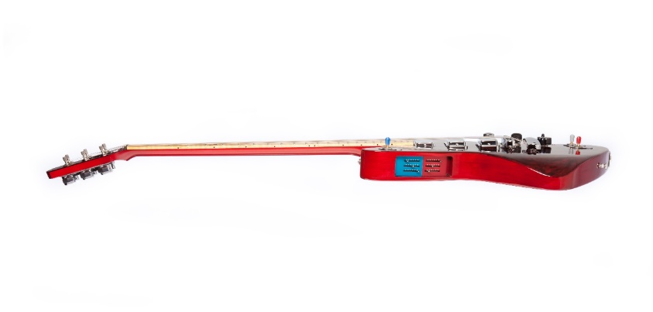Music for Stage and Screen.
* Fusions.

For more information, contact Mr Spacey.

**ASSESSMENT**

**Performance (30%)**

You will perform two pieces, one solo and one ensemble performance on an instrument (or voice) of your choice.

**Composing (30%)**

You will compose two pieces, one to a set brief and one as a free composition. We use the computers to compose.

**Final examination (40%)**

Our examination is based on 8 set works which we study in detail. In the examination you are asked a range of questions about what you can hear in the pieces using technical vocabulary.

**NEXT STEPS**

GCSE Music can lead to further study of music and music technology and onto careers in the fields of music, drama and teaching.

**PERFORMING ARTS**

**TECHNICAL AWARD**

**LEVEL 1 / 2 – PEARSON**

**COURSE OVERVIEW**

BTEC Performing Arts allows students to gain a broad understanding and knowledge of a range of performing styles and genres in a vocational context.

It is a valuable compliment to English, developing literacy and oracy through practical and written coursework and develops transferable interpersonal skills, including working with others and problem-solving.

**STAFF COMMENT**

*“This vocational course is ideal for students who want to develop their passion into a valuable skill set.”*

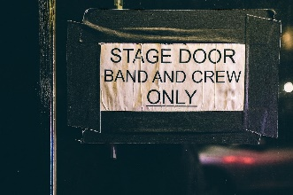

For more information, contact Mr Smith.

**WHAT’S COVERED?**

* Exploring the Performing Arts – Exploring key practitioners and styles in performance.
* Developing Skills and Techniques in the Performing Arts – experimenting with physical and vocal technique to develop your own skills in performance.
* Performing to a brief – Applying performance skills in response to a stimulus to create an externally assessed performance for a selected audience.

**ASSESSMENT**

You will be assessed by an external examination and on-going internal assessments, graded at pass, merit, distinction or distinction*.

**NEXT STEPS**

Level 3 study in Performing Arts or Drama. Apprenticeships within the creative industries sector.

**PHYSICAL EDUCATION**

**GCSE - AQA**

**COURSE OVERVIEW**

GCSE PE gives you chance to try your hand at a variety of sports and learn the theory behind why we train and what happens to our body when we play sport.

You will have 5 GCSE PE lessons per fortnight, 1 practical and 4 theory.

Due to the practical assessment within this course, it is recommended that students play for a club or school team or take part in extra-curricular sport.

**STUDENT COMMENT**

*“GCSE PE consists of more theory than practical, however is still fully enjoyable as the practical side supports my theoretical knowledge.”*



For more information, contact the PE Staff.

**WHAT’S COVERED? THEORY:**

* Anatomy and Physiology.
* Training Methods.
* Diet.
* Drugs.
* Sport Psychology.
* Sports Sociology.

**PRACTICAL:**

* Trampolining.
* Handball.
* Table Tennis.
* Hockey.
* Badminton.

**ASSESSMENT**

The theory (60%) is made up mostly of a written paper taken at the end of the two-year course. The practical assessment (40%) involves being assessed as a performer in three sports within a competitive situation.

**NEXT STEPS**

Careers in teaching, coaching, jobs in the leisure industry or in the emergency services.

**RELIGIOUS STUDIES**

**GCSE – AQA**

**COURSE OVERVIEW**

This course will lead to a thorough understanding and knowledge of religion in contemporary society.

There will be an emphasis on active learning, including the use of discussion, informed debate and role play.

**WHAT’S COVERED?**

* Crime and punishment.
* Life and death.
* Peace and conflict.
* Relationships and families.
* Beliefs, teachings and practices of Christianity and Judaism on the nature of God
* 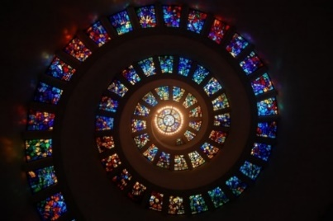Worship and festivals.

For more information, contact Mr Coomer.

**STAFF COMMENT**

*“Studying Religious Studies gives you an insight into a range of religions. In addition, you will improve your discussion and debating skills and give you a wider outlook on the society which we are living in.”*

**ASSESSMENT**

You will sit two examinations at the end of Year 11. There is no coursework. General spelling, grammar and punctuation are considered in the marking schemes for extended answers.

**NEXT STEPS**

GCSE Religious Studies has value for any career or educational course. It will show that you have a good understanding of religious and moral issues, and that you can make intelligent and informed judgements.

**SCIENCE –**

**COMBINED SCIENCE**

**2 GCSEs - AQA**

**COURSE OVERVIEW**

This is a concept-led course developed to meet the needs of students seeking an understanding of basic scientific ideas. The course focuses on scientific explanations and models, and gives candidates an insight into how scientists develop scientific understanding of ourselves and the world we inhabit.

**WHAT’S COVERED?**

* 7 topics of Biology.
* 10 topics of Chemistry.
* 7 topics of Physics.

There is an emphasis on scientific literacy, knowledge and understanding.



For more information, contact Mr Bracken.

**STUDENT COMMENT**

*“Combined Science has given me a great insight into the variety of things which are covered by science. I enjoy doing experiments in all 3 science subjects.”*

**ASSESSMENT**

You will sit 2 examinations for **each** subject (Biology, Chemistry and Physics). Each examination is 1 hour and 15 minutes long.

**NEXT STEPS**

This course works to prepare students for progression to further learning in the sciences in A Level subjects such as Biology, Chemistry, and Physics or vocational courses.

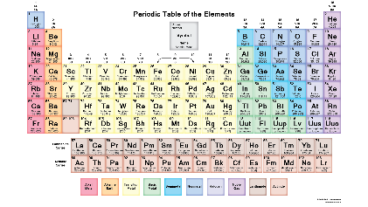

**SCIENCE –**

**SINGLE SCIENCES**

**3 GCSEs – AQA**

**COURSE OVERVIEW**

This specification provides distinctive and relevant experiences for more able candidates who wish to specialise in the separate sciences.

**WHAT’S COVERED?**

* 7 topics of Biology
* 10 topics of Chemistry
* 8 topics of Physics

These modules provide an opportunity for developing further understanding of scientific explanations, understanding of how science works and the study of elements of applied science with particular relevance to professional scientists.

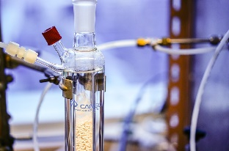

For more information, contact Mr Bracken.

**STAFF COMMENT**

*“Studying the sciences separately allows students to gain detailed knowledge on a range of scientific topics such as cell biology, chemical analysis and radioactivity. Students will learn scientific theories as well as practical application of science. A lot of students continue to study science at A Level.”*

**ASSESSMENT**

You will sit 2 examinations for **each** of the subjects. Each examination is 1 hour and 45 minutes.

**NEXT STEPS**

This course is ideal for students wishing to study individual sciences at A Level or vocational courses.

There is a wide range of careers in the science field such as aerospace, engineer, medicine/dentist and veterinary.

**SPORT STUDIES**

**CAMBRIDGE NATIONAL LEVEL 1 / 2 - OCR**

**COURSE OVERVIEW**

Four units are undertaken over the three year course. One Unit is an external examination. Other units are assignments or projects with most lessons computer based.

Cambridge Nationals are recognised by employers and education institutes as they help people to research and learn how to work independently. It introduces you to sport and the leisure industry and provides you with the knowledge, understanding and skills needed to prepare you for employment or progression onto further sports courses (Level 3 BTEC or A Level).

**STAFF COMMENT**

*“This course is ideal for students who enjoy completing coursework and assignments but still are passionate about taking part in sport.”*

For more information, contact Miss Gore or Mr Fenwick.

**WHAT’S COVERED?**

* Unit R051 – Contemporary Issues in Sport.
* Unit R052 – Developing Sports Skills.
* Unit R053 – Sports Leadership.
* Unit R054 –Sport and the Media.

**ASSESSMENT**

Each unit will be graded as a Pass, Merit, Distinction or Distinction*

Most units are assessed internally, students will be taught the content of the subject and set tasks to complete independently. Feedback is given by the teacher.

**NEXT STEPS**

This course provides the foundations for more advanced qualifications such as Sport BTEC Level 3. It prepares young people for careers in health, fitness, coaching and teaching.

**PAGES TO MAKE** [**NOTES**](http://tel:01253%20733192/)