15th September 2014

**To the Parents/Guardians of Year 7 students**

Dear Parent / Guardian,

**Re: Year 7 Cognitive Ability Tests (CATs)**

We wish to inform you that Year 7 will be involved in Cognitive Ability Tests (CATs) from week beginning Monday, 22nd September. These tests are completed on computers and will, therefore, be taken during three consecutive Computing lessons. Please note that headphones will be required during the tests; school will provide headphones, but your son/daughter may prefer to use their own personal MP3 headphones.

The CATs are made up of a series of short tests which assess a student’s reasoning and thinking abilities in key areas that support educational development and academic attainment. Cognitive Ability Tests are taken in schools throughout Lancashire and are used to help set target grades for young people starting secondary education.

The tests are not designed to require any specific revision and we do not want students and their parents/guardians to worry about them. However, the Cognitive Ability Tests are important and we would request that students do not miss any of their test sessions.

Test results will be issued with the first Year 7 school report.

If you have any questions regarding the Cognitive Ability Tests, please do not hesitate to contact the undersigned.

Yours sincerely,

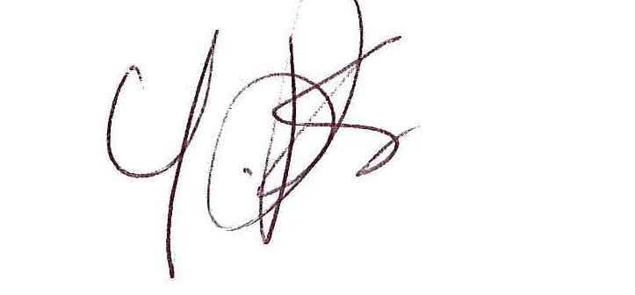

**Mrs. Y. Astley-Jones, Mrs. J. Gillespie,**

**Examinations Officer Deputy Headteacher**