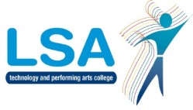 Accelerated Reader Information for Parents & Carers

The library is open to all Monday to Thursday 7:45-4:45pm & Friday 7:45am to 4pm
Including open access before school, at break, luncthtimes and after school.
LSA employs the Accelerated Reader (AR) scheme to encourage every student to read regularly both inside and outside of school. AR also helps us find books at the right level of challenge for each individual student, whatever their ability. Parents can support and monitor AR progress online with automatic email updates using Accelerated Reader Home Connect.
Level
6.2

2.5
Level
4.6

2.5
Level
7.7

2.5
Level
2.5

2.5
Level
3.1

2.5
Level
6.7

2.5
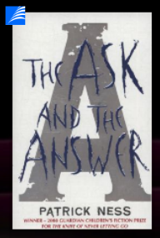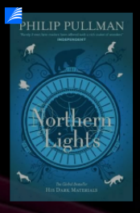

Books in the Library are clearly marked with a reading level. We often use books from specialist publishers to reach students with Zone at Proximal Devlopment (ZPD’s) below Level 4.5. If you have a large collection of reading books at home, many of these can be read as part of our reading scheme.

Lorna’s ZPD is 2.2-3.5 and she borrows from our Quick Read collection, gradually working her way up towards mainstream fiction. | Zak’s ZPD is 4.5-8.5, and we help him to find age-appropriate fiction or non-fiction that continues to stretch his advanced skills.

Students take a Star Reading Test each term to find their ZPD (zone of proximal development). In general, we encourage readers to choose books at a level around their own comfort zone: not too easy and not too hard. Every student in Year 7 & 8 has at least one AR lesson in English per fortnight to choose, swap books and get help if needed. Popular children’s books are on the AR scheme. English teachers monitor the reading program of students in their class and intervene where necessary. A teacher may intervene if she finds that a student isn’t reading or not making expected progress.

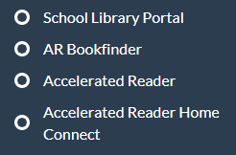 | Useful AR and Library tools can be found at the foot of each page of LSA’s website.  School Library Portal: Login as a guest user to search our collection.  AR Bookfinder: Use this website to search all AR books and find their interest & difficulty level.  Accelerated Reader: Student’s login to test their reading age (school time only) and quiz about books they have read (school time only) and check their progress towards termly targets.  Accelerated Reader Home Connect: Students can login to view your progress and bookshelf. Once your son/daughter has signed in, you can add your email (top right) to get regular progress updates.

