3rd March 2017

Dear Parents, Carers and Students,

**Year 8 Options Information**

Please find enclosed the 2017 Options Booklet which outlines details of the subjects currently on offer. The Options Choices Form is on the reverse of this letter.

Your recommended pathway is:

When choosing your options, aim for a broad curriculum which will allow you to achieve best results and secure an appropriate progression route post-16. You should remember however, that you are not choosing a career at this stage but rather that you are choosing subjects in which you will achieve best grades in at the end of Year 11. When choosing subjects think about what you are good at; where your best skills are and what you are interested in, as your chosen courses will be in place for three years and there is no facility to allow a student to swap or drop a subject part way through their Key Stage 4 course.

**Important Dates**

**9th March 2017 – Year 8 Options Evening 4:00-5:30pm**

**23rd March 2017 – Year 8 Parents’ Consultation Evening**

**29th March 2017 – DEADLINE for Year 8 Option Forms to be returned to Form Tutors**

I hope that the programme of events outlined above provides enough opportunity for you to gather all information but if you do have any remaining questions then please do not hesitate to get in touch with school and we will ensure that an appropriate person contacts you.

Yours faithfully,



Mrs J Gillespie

Deputy Headteacher

**Option Choices Form**

These are the option blocks which you can make your choices from.

You can choose one subject from each block, along with a reserve choice. This must be a genuine reserve which you haven’t chosen elsewhere. You also need to prioritise your choices.

If you take Triple Science, this will be your choice in **Option Block A**; you will then have 3 further choices.

If you take Double Science you will have 4 further choices.

To ensure you study a broad curriculum, you cannot choose:

Sport BTEC First Award **AND** PE GCSE

**OR**

Performing Arts BTEC Technical Award **AND** Drama GCSE

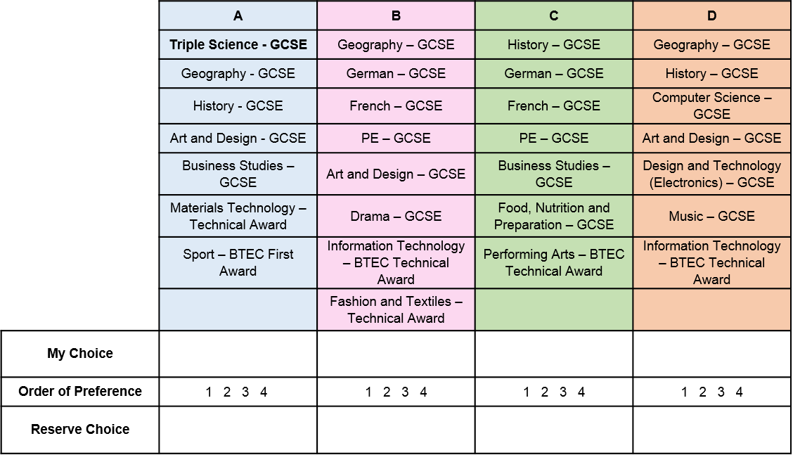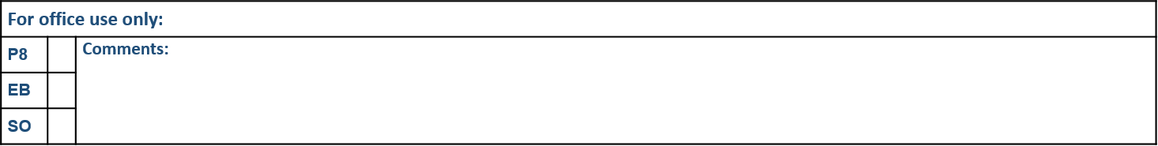

***The subjects offered may be reviewed should there be any changes in specifications or staffing.***

***Students, Parents and Carers should understand, that subjects chosen will be studied until the end of Year 11 and that there is no facility to change or drop a subject part way through.***